**Name: Session:**

**Programming II**

**Lab Exercise 3.26.2020**

**Argument Passing to Functions**

1. Write an application that accepts from the user the wholesale cost of an item and it’s markup percentage. The program should contain a function displayRetail that will take the wholesale cost and markup percentage and displays the retail cost in a label.

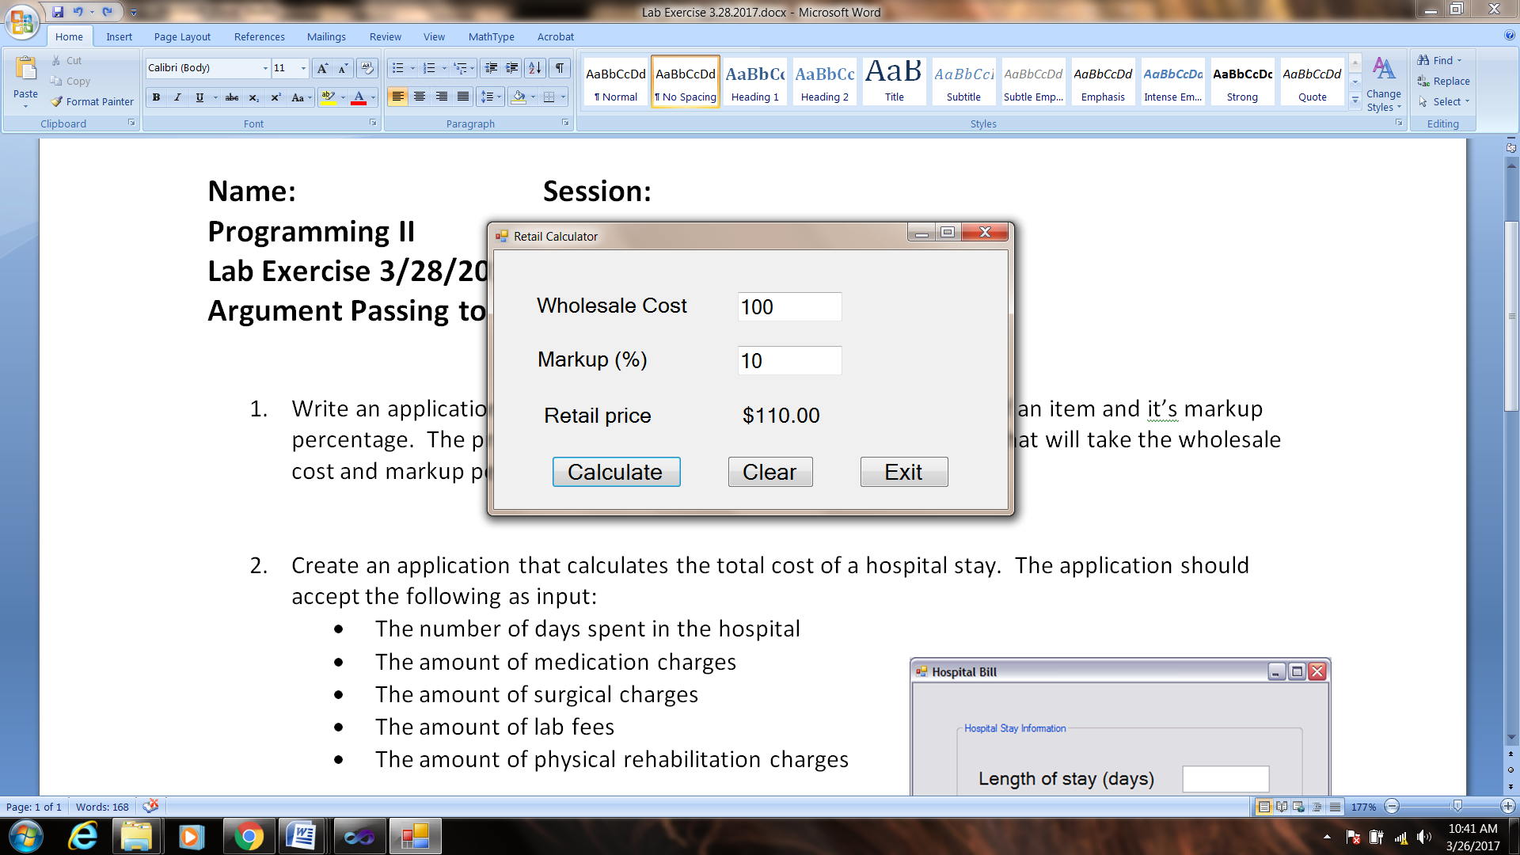

1. Create an application that calculates the total cost of a hospital stay. The application should accept the following as input:

* The number of days spent in the hospital
* 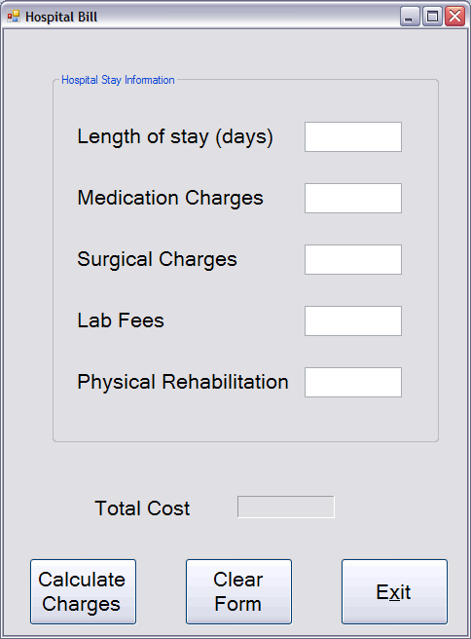The amount of medication charges
* The amount of surgical charges
* The amount of lab fees
* The amount of physical rehabilitation charges

The hospital charges $350 per day

Your program should have the following functions:

* calcStayCharges – days x cost/day
* calcMiscCharges – medication + surgical + lab
* calcTotalCharges – stay charges + miscellaneous

**When you have completed application 1 and 2, print a screenshot of your running application (with data) and turn in with your source code attached to this sheet.**